Problem 1: Cache Access-Time & Performance

Ben is trying to determine the best cache configuration for a new processor. He knows how to build two kinds of caches: direct-mapped caches and 4-way set-associative caches. The goal is to find the better cache configuration with the given building blocks. He wants to know how these two different configurations affect the clock speed and the cache miss-rate, and choose the one that provides better performance in terms of average latency for a load.

Problem 1.A | Access Time: Direct-Mapped

Now we want to compute the access time of a direct-mapped cache. We use the implementation shown in Figure 1. Assume a 128-KB cache with 8-word (32-byte) cache lines. The address is 32 bits and byte-addressed, so the two least significant bits of the address are ignored since a cache access is word-aligned. The data output is also 32 bits (1 word), and the MUX selects one word out of the eight words in a cache line. Using the delay equations given in Table 2.1-1, fill in the column for the direct-mapped (DM) cache in the table. In the equation for the data output driver, ‘associativity’ refers to the associativity of the cache (1 for direct-mapped caches, A for A-way set-associative caches). (4 points)
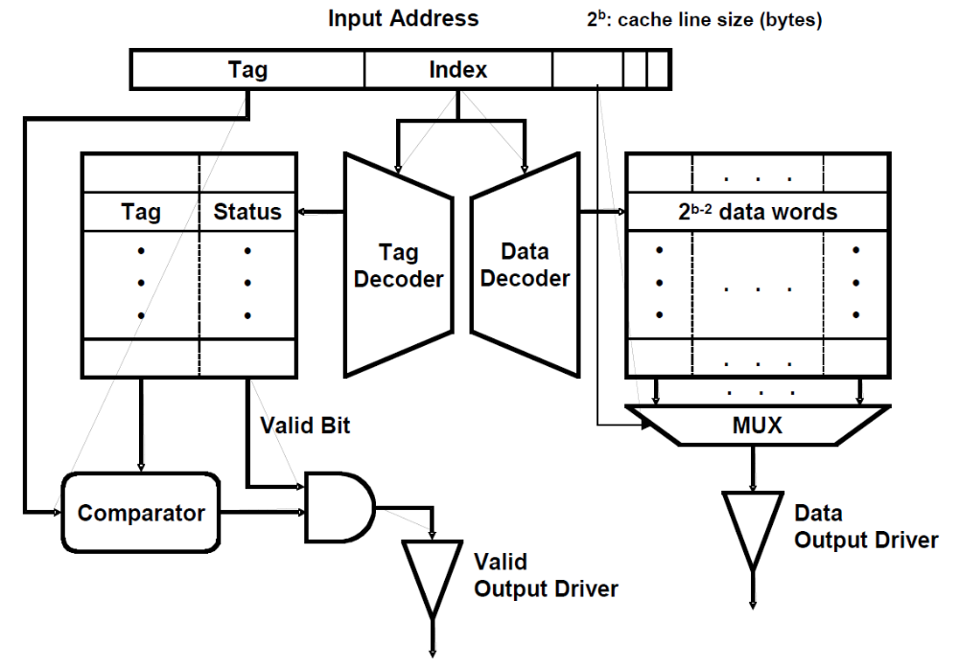

Figure 1 A direct-mapped cache implementation

Component | Delay equation (ps) |  | DM (ps) | SA (ps)
Decoder | 20×(# of index bits) + 100 | Tag | 340 | 300
Decoder | 20×(# of index bits) + 100 | Data | 340 | 300
Memory array | 20× log₂ (# of rows) +  20× log₂ (# of bits in a row) + 100 | Tag | 422 | 425
Memory array | 20× log₂ (# of rows) +  20× log₂ (# of bits in a row) + 100 | Data | 500 | 500
Comparator | 20×(# of tag bits) + 100 |  | 400 | 440
N-to-1 MUX | 50×log₂ N + 100 |  | 250 | 250
Buffer driver | 200 |  |  | 200
Data output driver | 50×(associativity) + 100 |  | 150 | 300
Valid output driver | 100 |  | 100 | 100

Table 2.1-1: Delay of each Cache Component

What is the critical path of this direct-mapped cache for a cache read? What is the access time of the cache (the delay of the critical path)? To compute the access time, assume that a 2-input gate (AND, OR) delay is 50 ps. If the CPU clock is 1.5 GHz, how many CPU cycles does a cache access take? (6 points)

To use the delay equations, we need to know how many bits are in the tag and how many
are in the index. We are given that the cache has 32-byte lines, which means that there
are 5 offset bits. However, we are also told that the bottom two bits are ignored, which
appears in the calculation for the word-select mux delay, which is an 8-way mux.
In a 128 KB direct-mapped cache with 8 word (32B) cache lines, there are 4096 = 2¹²
cache lines (128KB/32B). Therefore, there are 12 index bits. Subtracting the 12 index bits
and the 5 offset bits from the 32-bit address, it is clear that there must be 15 tag bits.

We also need the number of rows and the number of bits per row in the tag & data
memories. The number of rows is simply the number of cache lines (4096), which is the
same for both the tag and the data memory. The number of bits in a row for the tag
memory is the sum of the number of tag bits (15) and the number of status bits (2), which
yields 17 bits total. The number of bits in a row for the data memory is the number of bits
in a cache line, which is 256 for a 32-byte cache line.

With 8 words in the cache line, we need an 8-to-1 MUX. Since there is only one data
output driver, its associativity is 1.

Decoder (Tag) = 20 × (# of index bits) + 100 = 20 × 12 + 100 = 340 ps
Decoder (Data) = 20 × (# of index bits) + 100 = 20 × 12 + 100 = 340 ps
Memory array (Tag) = 20 × log₂(# of rows) + 20 × log₂(# bits in a row) + 100
= 20 × log₂(2¹²) + 20 × log₂(17) + 100 ≈ 422 ps
Memory array (Data) = 20 × log₂(# of rows) + 20 × log₂(# bits in a row) + 100
= 20 × log₂(2¹²) + 20 × log₂(256) + 100 = 500 ps
Comparator = 20 × (# of tag bits) + 100 = 20 × 15 + 100 = 400 ps

N-to-1 MUX = 50 × log₂(N) + 100 = 50 × log₂(8) + 100 = 250 ps
Data output driver = 50 × (associativity) + 100 = 500 × 1 + 100 = 150 ps

To determine the critical path for a cache read, we need to compute the time it takes to go
through each path in hardware (tag check and data read). By taking the maximum delay
of these two paths, we are left with the critical path.
Time to tag check valid driver = (tag decode time) + (tag memory access time) + (comparator time) + (AND gate time) + (valid output driver time)
≈ 340 + 422 + 400 + 50 + 100 = 1312 ps
Time to data output driver = (data decode time) + (data memory access time) + (mux time) + (data output driver time)
= 340 + 500 + 250 + 150 = 1240 ps

From the above calculations, we see that the tag check is the critical path. The access
time is 1312 ps. At 1.5 GHz, this cache access takes (1312 ps / (1 / 1.5GHz)) ≈ 2 cycles.
Here, rounding up to the nearest cycle is sensible, as this reflects how a synchronous
system would actually work.

Problem 1.B | Access Time: Set-Associative

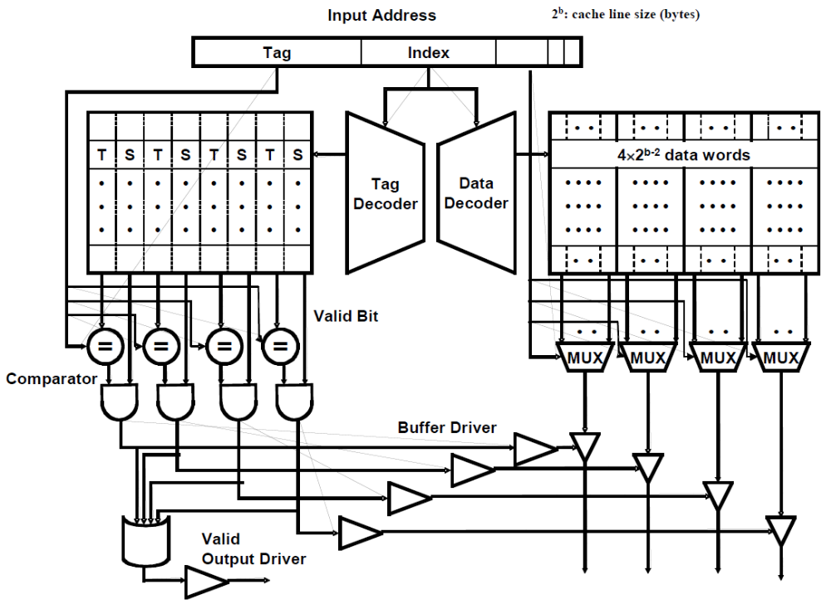
Figure 2 A 4-way set-associative cache implementation
We also want to investigate the access time of a set-associative cache using the 4-way set-associative cache in Figure 2. Assume the total cache size is still 128-KB (each way is 32-byes), a 4-input gate delay is 100 ps, and all other parameters (such as the input address, cache line, etc.) are the same as part 2.1.A. Compute the delay of each component, and fill in the column for a 4-way set-associative cache in Table 2.1-1. (5 points)

What is the critical path of the 4-way set-associative cache? What is the access time of the cache (the delay of the critical path)? What is the main reason that the 4-way set-associative cache is slower than the direct-mapped cache? If the CPU clock is 1.5 GHz, how many CPU cycles does a cache access take? (8 points)

As in 1.A, we have a 32-byte cache lines and a 5-bit offset, of which only the top three
bits are used to select an output word. However, the number of tag and index bits has
changed.
Index bits: ((128kB cache / 4 ways) / 32B line) = 1024 sets => 10 index bits
Tag bits: (32-bit address) - (10-bit index) - (5-bit offset) => 17 tag bits
# of rows in the tag/data memories: 1024 sets => 1024 rows
# of bits in a tag memory row: 4 x (17-bit tag + 2-bit status) => 76 bits
# of bits in a data memory row: 4 x (32B line) => 1024 bits
We now have all the numbers required to fill in the table for the SA cache.
Decoder (Tag) = 20 × (# of index bits) + 100 = 20 × 10 + 100 = 300 ps
Decoder (Data) = 20 × (# of index bits) + 100 = 20 × 10 + 100 = 300 ps
Memory array (Tag) = 20 × log₂(1024) + 20 × log₂(76) + 100 = 425 ps
Memory array (Data) = 20 × log₂(1024) + 20 × log₂(1024) + 100 = 500 ps
Comparator = 20 × (# of tag bits) + 100 = 20 × 17 + 100 = 440 ps
N-to-1 MUX = 50 × log₂(N) + 100 = 50 × log2(8) + 100 = 250 ps
Data output driver = 50 × (associativity) + 100 = 50 × 4 + 100 = 300 ps
Valid output driver = 100 ps
Time to valid output driver = (tag decode time) + (tag memory access time) + (comparator time) + (AND gate time) + (OR gate time) + (valid output driver time)
= 300 + 425 + 440 + 50 + 100 + 100 = 1415 ps

There are two paths to the data output drivers, one from the tag side, and one from the
data side. Either may determine the critical path to the data output drivers, so we must
calculate the delay of each.

Time to get through data output driver through tag side = (tag decode time) + (tag memory access time) + (comparator time) + (AND gate time) + (buffer driver time) + (data output driver)
= 300 + 425 + 440 + 50 + 200 + 300 = 1715 ps
Time to get through data output driver through data side = (data decode time) + (data memory access time) + (mux time) + (data output driver)
= 300 + 500 + 250 + 300 = 1350 ps

From the above calculations, it’s clear that the critical path is the path to select the
appropriate data output driver based on the tag check.

The access time is 1715 ps. At 1.5 GHz, this cache access takes (1715 ps / (1 / 1.5GHz)) ≈ 3 cycles. Here, rounding up to the nearest cycle is sensible, as this reflects how a synchronous system would actually work.

Problem 1.C | Miss-rate analysis

Now Ben is studying the effect of set-associativity on the cache performance. Since he now knows the access time of each configuration, he wants to know the miss-rate of each one. For the miss-rate analysis, Ben is considering two small caches: a direct-mapped cache with 8 lines with 16 bytes/line, and a 4-way set-associative cache of the same size and line size. For the set-associative cache, Ben tries out two replacement policies – least recently used (LRU) and round robin (FIFO).

Ben tests the cache by accessing the following sequence of hexadecimal byte addresses, starting with empty caches. For simplicity, assume that the addresses are only 12 bits. Complete the following tables for the direct-mapped cache and both types of 4-way set-associative caches showing the progression of cache contents as accesses occur (in the tables, ‘inv’ = invalid, and the column of a particular cache line contains the tag of that line). Also, for each address calculate the tag and index (which should
help in filling out the table). You only need to fill in elements in the table when a value changes. (21 points)

address = 12 bits addr[11:0]
tag = 5 bits addr[11:7] (12 bits - index_sz - offset_sz)
index = 3 bits addr[6:4] (2^3 = 8 lines)
offset = 4 bits addr[3:0] (2^4 = 16 bytes/line)

D-map  Address | Addresses and tags are in HEX
D-map  Address | line in cache (tag) |  |  |  |  |  |  |  | hit?
D-map  Address | L0 | L1 | L2 | L3 | L4 | L5 | L6 | L7
110 | inv | 2 | inv | inv | inv | inv | inv | inv | no
136 |  |  |  | 2 |  |  |  |  | no
202 | 4 |  |  |  |  |  |  |  | no
1A3 |  |  | 3 |  |  |  |  |  | no
102 | 2 |  |  |  |  |  |  |  | no
361 |  |  |  |  |  |  | 6 |  | no
204 | 4 |  |  |  |  |  |  |  | no
114 |  |  |  |  |  |  |  |  | yes
1A4 |  |  |  |  |  |  |  |  | yes
177 |  |  |  |  |  |  |  | 2 | no
301 | 6 |  |  |  |  |  |  |  | no
206 | 4 |  |  |  |  |  |  |  | no
135 |  |  |  |  |  |  |  |  | yes

 | D-map
Total Misses | 10
Total Accesses | 13

address = 12 bits addr[11:0]
tag = 7 bits addr[11:5] (12 bits - index_sz - offset_sz)
index = 1 bits addr[4] (2^1 = 2 sets)
offset = 4 bits addr[3:0] (2^4 = 16 bytes/line)

4-way  Address | LRU -- addresses and tags are in HEX
4-way  Address | line in cache |  |  |  |  |  |  |  | hit?
4-way  Address | Set 0 |  |  |  | Set 1 |  |  |  | hit?
4-way  Address | way0 | way1 | Way2 | way3 | way0 | way1 | way2 | way3
110 | Inv | Inv | Inv | inv | 8 | inv | inv | inv | no
136 |  |  |  |  |  | 9 |  |  | no
202 | 10 |  |  |  |  |  |  |  | no
1A3 |  | 0D |  |  |  |  |  |  | no
102 |  |  | 08 |  |  |  |  |  | no
361 |  |  |  | 1B |  |  |  |  | no
204 | √ |  |  |  |  |  |  |  | yes
114 |  |  |  |  | √ |  |  |  | yes
1A4 |  | √ |  |  |  |  |  |  | yes
177 |  |  |  |  |  |  | 0B |  | no
301 |  |  | 18 |  |  |  |  |  | no
206 | √ |  |  |  |  |  |  |  | yes
135 |  |  |  |  |  | √ |  |  | yes

 | 4-way LRU
Total Misses | 8
Total Accesses | 13

4-way  Address | FIFO -- addresses and tags are in HEX
4-way  Address | line in cache (tag) |  |  |  |  |  |  |  | hit?
4-way  Address | Set 0 |  |  |  | Set 1 |  |  |  | hit?
4-way  Address | way0 | way1 | way2 | way3 | way0 | way1 | way2 | way3
110 | inv | inv | inv | inv | 8 | inv | inv | inv | no
136 |  |  |  |  |  | 9 |  |  | no
202 | 10 |  |  |  |  |  |  |  | no
1A3 |  | 0D |  |  |  |  |  |  | no
102 |  |  | 08 |  |  |  |  |  | no
361 |  |  |  | 1B |  |  |  |  | no
204 | √ |  |  |  |  |  |  |  | yes
114 |  |  |  |  | √ |  |  |  | yes
1A4 |  | √ |  |  |  |  |  |  | yes
177 |  |  |  |  |  |  | 0B |  | no
301 | 18 |  |  |  |  |  |  |  | no
206 |  | 10 |  |  |  |  |  |  | no
135 |  |  |  |  |  | √ |  |  | yes

 | 4-way FIFO
Total Misses | 9
Total Accesses | 13

Problem 1.D | Average Latency

Assume that the results of the above analysis can represent the average miss-rates of the direct-mapped and the 4-way set-associative 128-KB caches studied in 1.A and 1.B. What would be the average memory access latency in CPU cycles for each cache (assume that the cache miss penalty is 20 cycles)? Which one is better? For the different replacement policies for the set-associative cache, which one has a smaller cache miss rate for the address stream in 1.C? Explain why. Is that replacement policy always going to yield better miss rates? If not, give a counter example using an address stream. (8 points)

The miss rate for the direct-mapped cache is 10/13. The miss rate for the 4-way LRU set associative cache is 8/13.
The average memory access latency is (hit time) + (miss rate) × (miss penalty).
For the direct-mapped cache, the average memory access latency would be:
(2 cycles) + (10/13) × (20 cycles) = 17.4 cycles.
For the LRU set-associative cache, the average memory access latency would be:
(3 cycles) + (8/13) × (20 cycles) = 15.3 cycles.
For the FIFO set-associative cache, the average memory access latency would be:
(3 cycles) + (9/13) × (20 cycles) = 16.8 cycles.
The set-associative cache with LRU replacement is better than the direct-mapped cache
in terms of average memory access latency.
For the above example, LRU has a slightly smaller miss rate than FIFO. This is because
the FIFO policy replaced the {20} block instead of the {10} block during the 12th access,
because the {20} block has been in the cache longer, even though the {10} was least
recently used. In this case, the LRU policy took better advantage of temporal locality.
LRU does not always outperform FIFO. Assume we have a set-associative cache with the
same parameters as in 1.C and an access sequence shown below. There is a miss with
LRU for the last access while there is a hit with FIFO.
0x100
0x120
0x140
0x160
0x100
0x180
0x120

Problem 2: Loop Ordering

This problem evaluates the cache performances for different loop orderings. You are asked to consider the following two loops, written in C, which calculate the sum of the entries in a 128 by 32 matrix of 32-bit integers:

Loop A | Loop B
sum = 0;  for (i = 0; i < 128; i++)  for (j = 0; j < 32; j++)  sum += A[i][j]; | sum = 0;  for (j = 0; j < 32; j++)  for (i = 0; i < 128; i++)  sum += A[i][j];

The matrix A is stored contiguously in memory in row-major order. Row major order means that elements in the same row of the matrix are adjacent in memory as shown in the following memory layout:

A[i][j] resides in memory location [4*(32*i + j)]

Memory Location:

0 | 4 |  |  | 124 | 128 |  | 4*(32*127+31)
A[0][0] | A[0][1] |  | ... | A[0][31] | A[1][0] | ... | A[127][31]

For Problem 2.A to Problem 2.C, assume that the caches are initially empty. Also, assume that only accesses to matrix A cause memory references and all other necessary variables are stored in registers. Instructions are in a separate instruction cache.

Problem 2.A

Consider a 4KB direct-mapped data cache with 8-word (32-byte) cache lines.
Calculate the number of cache misses that will occur when running Loop A.
Calculate the number of cache misses that will occur when running Loop B. (6 points)

Each element of the 128x32 matrix A can only be mapped to one particular cache
location in this direct-mapped data cache. Since each row has 32 32-bit integers, and
since each cache line can hold 8 32-bit words, a row of the matrix occupies the lines in
four consecutive sets of the cache.
Loop A—where each iteration of the inner loop sums a row of A—accesses memory
addresses in a linear sequence. Given this access pattern, the access to the first word in
each cache line will miss, but the next seven accesses will hit. After sequentially moving
through this line, it will not be accessed again, so its later eviction will not cause any
future misses. Therefore, Loop A will only have compulsory misses for the 512 (128
rows x 4 lines per row) that matrix A spans.
The consecutive accesses in Loop B will move in a stride of 32 bytes. Therefore, the
inner loop will touch the first element in 128 cache lines before the next iteration of the
outer loop. While intuition might suggest that the 128 lines could all fit in the cache with
128 sets, there is a complicating factor: each row is four cache lines past the previous
row, meaning that the lines accessed when traversing the first column go in indices 0, 4,
8, 12, and so on. Since the lines containing the column are competing for only one fourth
of the sets, the lines loaded when starting a column are evicted by the time the column is
complete, preventing any reuse. Therefore, all 4096 (128 x 32) accesses miss.

The number of cache misses for Loop A:________512_____________________

The number of cache misses for Loop B:________4096_____________________

Problem 2.B

Consider a direct-mapped data cache with 8-word (32-byte) cache lines. Calculate the minimum number of cache lines required for the data cache if Loop A is to run without any cache misses other than compulsory misses. Calculate the minimum number of cache lines required for the data cache if Loop B is to run without any cache misses other than compulsory misses. (6 points)

Since Loop A accesses memory sequentially, we can sum all the elements in a cache line
and then never touch it again. Therefore, we only need to hold 1 active line at any given
time to avoid all but compulsory misses.
For Loop B to run without any cache misses other than compulsory misses, the data
cache needs to have the ability to hold one column of matrix A in the cache. Since the
consecutive accesses in the inner loop of Loop B will use every fourth cache line, and
since we have 128 rows, Loop B requires 512 (128 × 4) lines to avoid all but compulsory misses.

Data-cache size required for Loop A: __________1__________________ cache line(s)

Data-cache size required for Loop B: __________512_________________ cache line(s)

Problem 2.C

Consider a 4KB fully-associative data cache with 8-word (32-byte) cache lines. This data cache uses a first-in/first-out (FIFO) replacement policy.
Calculate the number of cache misses that will occur when running Loop A.
Calculate the number of cache misses that will occur when running Loop B.

Loop A still only has 512 (128 rows x 4 lines per row) compulsory misses.
Because of the fully-associative data cache, Loop B now can fully utilize the cache and
the consecutive accesses in Loop B will no longer use every fourth cache line. Therefore,
we can fit 8 columns in the cache after taking one compulsory miss on each, and we can
reuse all the remaining elements in each line before evicting them. This means that loop
B experiences only (128 rows x 4 lines per row) compulsory misses. (2 points)

The number of cache misses for Loop A:__________512__________________(2 points)

The number of cache misses for Loop B:__________512__________________(2 points)

Problem 3: Microtagged Cache

In this problem, we explore microtagging, a technique to reduce the access time of set-associative caches. Recall that for associative caches, the tag check must be completed before load results are returned to the CPU, because the result of the tag check determines which cache way is selected. Consequently, the tag check is often on the critical path.

The time to perform the tag check (and, thus, way selection) is determined in large part by the size of the tag. We can speed up way selection by checking only a subset of the tag—called a microtag—and using the results of this comparison to select the appropriate cache way. Of course, the full tag check must also occur to determine if the cache access is a hit or a miss, but this comparison proceeds in parallel with way selection. We store the full tags separately from the microtag array.

We will consider the impact of microtagging on a 4-way set-associative 16KB data cache with 32-byte lines. Addresses are 32 bits long. Microtags are 8 bits long. The baseline cache (i.e. without microtagging) is depicted in Figure 2. Figure 3, below, shows the modified tag comparison and driver hardware in the microtagged cache.

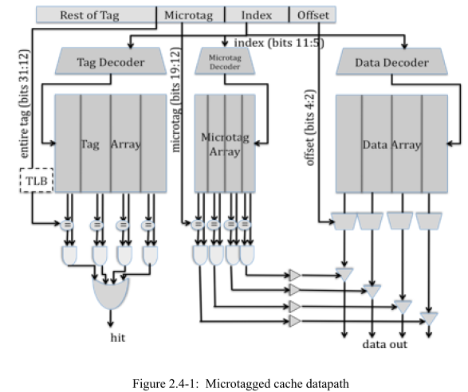
Figure 3 Microtagged Cache

Problem 3.A | Cache Cycle Time

Table 2.4-1, below, contains the delays of the components within the 4-way set-associative cache, for both the baseline and the microtagged cache. For both configurations, determine the critical path and the cache access time (i.e., the delay through the critical path). Fill in the columns for the microtagged cache.

Assume that the 2-input AND gates have a 50ps delay and the 4-input OR gate has a 100ps delay. (3 points)

Component | Delay equation (ps) |  | Baseline | Microtagged
Decoder | 20×(# of index bits) + 100 | Tag | 240 | 240
Decoder | 20×(# of index bits) + 100 | Data | 240 | 240
Memory array | 20×log₂ (# of rows) +  20×log₂ (# of bits in a row) + 100 | Tag | 369 | 369
Memory array | 20×log₂ (# of rows) +  20×log₂ (# of bits in a row) + 100 | Data | 440 | 440
Memory array | 20×log₂ (# of rows) +  20×log₂ (# of bits in a row) + 100 | Microtag |  | 346  (tag 8 bits +  valid 1 bit + dirty 1 bit)
Comparator | 20×(# of tag bits) + 100 | Tag | 500 | 500
Comparator | 20×(# of tag bits) + 100 | Microtag |  | 260
N-to-1 MUX | 50×log₂ N + 100 |  | 250 | 250
Buffer driver | 200 |  | 200 | 200
Data output driver | 50×(associativity) + 100 |  | 300 | 300
Valid output driver | 100 |  | 100 | 100

Table 2.4-1: Delay of each Cache Component

What is the old critical path? The old cycle time (in ps)? (4 points)

Candidate 1: Full tag check
tag decoder → tag read → comparator → 2-in AND → 4-in OR → valid output driver
240 ps + 369 ps + 500 ps + 50 ps + 100 ps + 100 ps = 1359 ps
Candidate 2: Data select based on full tag check
tag decoder → tag read → comparator → 2-in AND → buffer driver → data output driver
240 ps + 369 ps + 500 ps + 50 ps + 200 ps + 300 ps = 1659 ps
Candidate 3: Data readout
data decoder → data read → 4-to-1 MUX → data output driver
240 ps + 440 ps + 250 ps + 300 ps = 1230 ps
The critical path is the data select based on the full tag match. The cycle time is 1659 ps.

What is the new critical path? The new cycle time (in ps)? (4 points)

Candidate 1: Full tag check same as baseline => 1359 ps
Candidate 2: Data select based on microtag check μtag decoder → μtag read →comparator → 2-in AND → buffer driver → data out driver
240 ps + 346 ps + 260 ps + 50 ps + 200 ps + 300 ps = 1396 ps
Candidate 3: Data readout
same as baseline => 1230 ps
The critical path is the data select based on the microtag. The cycle time is 1390 ps.

Problem 3.B | AMAT
Assume temporarily that both the baseline cache and the microtagged cache have the same hit rate, 95%, and the same average miss penalty, 20 ns. Using the cycle times computed in 3.A as the hit times, compute the average memory access time for both caches. What was the old AMAT (in ns)? What is the new AMAT (in ns)? (4 points)

AMAT = (hit_time) + (miss)_rate x (miss_penalty) = X + (0.05)(20ns) = X + 1ns, where
X is the hit time calculated from 3.A
Old AMAT = 1.659 + 1 = 2.659 ns
New AMAT with microtags = 1.396 + 1 = 2.396 ns

Problem 3.C | Constraints

Microtags add an additional constraint to the cache: in a given cache set, all microtags must be unique. This constraint is necessary to avoid multiple microtag matches in the same set, which would prevent the cache from selecting the correct way.

State which of the 3C’s of cache misses this constraint affects. How will the cache miss rate compare to an ordinary 4-way set-associative cache? How will it compare to that of a direct-mapped cache of the same size? (4 points)

Because the uniqueness property of microtags restricts the replacement policy, the cache
isn’t free to make as optimal replacement decisions as it could in the baseline. This will
lead to some increase in conflict misses. The magnitude of this effect depends on which 8
bits are selected to form the microtag. In principle, using the bottom 8 bits would result in
more potential for microtag collisions and would add the biggest restriction to the ability
of the cache to hold spatially local data. However, it will still be better than a direct mapped cache of the same size and line size.

Problem 4: Victim Cache Evaluation

Although direct-mapped caches have an advantage of smaller access time than set- associative caches, they have more conflict misses due to their lack of associativity. In order to reduce these conflict misses, Norm Jouppi proposed victim caching, where a small fully-associative back up cache, called a victim cache, is added to a direct-mapped L1 cache to hold recently evicted cache lines.

The following diagram shows how a victim cache can be added to a direct-mapped L1 data cache. Upon a data access, the following chain of events takes place:

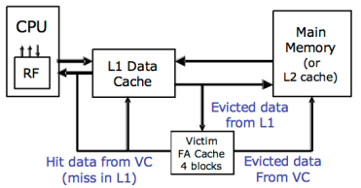

- The L1 data cache is checked. If it holds the data requested, the data is returned.
- If the data is not in the L1 cache, the victim cache is checked. If it holds the data requested, the data is moved into the L1 cache and sent back to the processor. The data evicted from the L1 cache is put in the victim cache, and put at the end of the FIFO replacement queue.
- If neither of the caches holds the data, it is retrieved from memory, and put in the L1 cache. If the L1 cache needs to evict old data to make space for the new data, the old data is put in the victim cache and placed at the end of the FIFO replacement queue. Any data that needs to be evicted from the victim cache to make space is written back to memory or discarded, if unmodified.

Note that the two caches are exclusive. That means that the same data cannot be stored in both L1 and victim caches at the same time.

Problem 4.A | Baseline Cache Design

The diagram below shows our victim cache, a 32-Byte fully associative cache with four 8-Byte cache lines. Each line contains of two 4-Byte words and has an associated tag and two status bits (valid and dirty). The Input Address is 32-bits and the two least significant bits are assumed to be zero. The output of the cache is a 32-bit word.

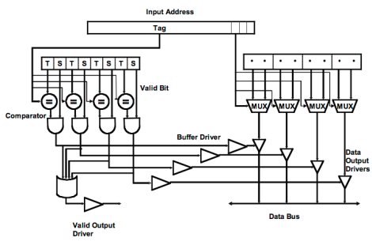
Figure 4: Victim cache datapath

Please complete Table 2.5-1 with delays across each element of the cache. Using the data you compute in Table 2.5-1, calculate the critical path delay through this cache (from when the Input Address is set to when both Valid Output Driver and the appropriate Data Output Driver are outputting valid data). (4 points)

Component | Delay equation (ps) | Delay(ps)
Comparator | 20×(# of tag bits) + 100 | 680
N-to-1 MUX | 50×log₂ N + 100 | 150
Buffer driver | 200 | 200
AND gate | 100 | 100
OR gate | 50× log₂ N + 100 | 200
Data output driver | 50×(associativity) + 100 | 300
Valid output driver | 100 | 100
Table 2.5-1: Delay of each cache component

Critical Path Cache Delay: (4 points)

Below, we evaluate the three major paths through the victim cache to find the critical
path and cycle time. Note that the victim cache is fully-associative and uses 29-bit tags.
Candidate 1: Tag check
comparator → 2-in AND → 4-in OR → valid output driver
680 ps + 100 ps + 200 ps + 100 ps = 1080 ps
Candidate 2: Data select based on tag check
comparator → 2-in AND → buffer driver → data output driver
680 ps + 100 ps + 200 ps + 300 ps = 1280 ps
Candidate 3: Data readout
2-to-1 MUX → data output driver
200 ps + 300 ps = 500 ps
The critical path is the data select based on the tag match. The cycle time is 1280 ps.

Problem 4.B | Victim Cache Behavior

Now we will study the impact of a victim cache on cache hit rate. Our main L1 cache is a 128 byte, direct-mapped cache with 16 bytes per cache line. The cache is word (4-bytes) addressable. The victim cache in Figure 4 is a 32-byte fully associative cache with 16 bytes per cache line, and is also word addressable. The victim cache uses the first in first out (FIFO) replacement policy.

Please complete Table 2.5-2 showing a trace of memory accesses. In the table, each entry contains the tag of that line, or “inv”, if no data is present. You should only fill in elements in the table when a value changes. For simplicity, the addresses are only 8 bits. The first 3 lines of the table have been filled in for you. For your convenience, the address breakdown for access to the main cache is depicted below. (11 points)

Input Address | Main Cache (tag) |  |  |  |  |  |  |  |  | Victim Cache (tag)
 | L0 | L1 | L2 | L3 | L4 | L5 | L6 | L7 | Hit? | Way0 | Way1 | Hit?
 | inv | inv | inv | inv | inv | inv | inv | inv | - | inv | inv | -
0 | 0 |  |  |  |  |  |  |  | N |  |  | N
80 | 1 |  |  |  |  |  |  |  | N | 0 |  | N
4 | 0 |  |  |  |  |  |  |  | N | 8 |  | Y
A0 |  |  | 1 |  |  |  |  |  | N |  |  | N
10 |  | 0 |  |  |  |  |  |  | N |  |  | N
C0 |  |  |  |  | 1 |  |  |  | N |  |  | N
18 |  | 0 |  |  |  |  |  |  | Y
20 |  |  | 0 |  |  |  |  |  | N |  | A | N
8C | 1 |  |  |  |  |  |  |  | N | 0 |  | Y
28 |  |  | 0 |  |  |  |  |  | Y
AC |  |  | 1 |  |  |  |  |  | N |  | 2 | Y
38 |  |  |  | 0 |  |  |  |  | N |  |  | N
C4 |  |  |  |  | 1 |  |  |  | Y
3C |  |  |  | 0 |  |  |  |  | Y
48 |  |  |  |  | 0 |  |  |  | N | C |  | N
0C | 0 |  |  |  |  |  |  |  | N |  | 8 | N
24 |  |  | 0 |  |  |  |  |  | N | A |  | N
Table 2.5-2: Memory access trace

Problem 4.C | Average Memory Access Time

Assume 15% of memory accesses are resolved in the victim cache. If retrieving data from the victim cache takes 5 cycles and retrieving data from main memory takes 55 cycles, by how many cycles does the victim cache improve the average memory access time? (2 points)

15% of accesses will take 50 cycles less to complete, so the average memory access
improvement is 0.15 * 50 = 7.5 cycles.
Problem 5: Three C’s of Cache Misses

Mark whether the following modifications will cause each of the categories to increase, decrease, or whether the modification will have no effect. You can assume the baseline cache is set associative. Explain your reasoning. (12 points)

 | Compulsory Misses | Conflict Misses | Capacity Misses
Double the associativity  (capacity and line size constant) | No effect  Doubling associativity doesn’t  change when lines are first  brought into the cache | Decrease  Typically, higher  associativity reduces  conflict misses, since  there are more places to  put the same element. | No effect  Capacity does not change.
Halving the line size  (associativity and  # sets constant)  Halves capacity! | Increase  Shorter lines mean fewer adjacent  elements are brought in with the  first access to a given line. | Increase  The program will access more  cache lines in total, creating more  opportunity for conflict misses. | Increase  Capacity has been cut in  half.
Doubling the number of sets  (capacity and line size constant)  Halves associativity! | No effect  Halving associativity doesn’t  change when lines are first  brought into the cache | Increase  Typically, lower  associativity increases  conflict misses, since  there are fewer places to  put the same element. | No effect  Capacity does not change.

 | Compulsory Misses | Conflict Misses | Capacity Misses
Adding prefetching | Decrease  Ideally, a good  prefetcher can bring data  in before we use it, avoiding  compulsory misses. | Best answer: Decrease  With good prefetching, conflict  misses should decrease, as the  prefetcher will often bring lines  that have been evicted back into  the cache.  Okay answer: increase  With mediocre prefetching,  conflict misses could increase, as  the prefetcher could evict useful  lines to bring in useless.  Other okay answer: no effect  With mediocre prefetching that  uses a stream buffer or other  ancillary structure, there will be  little to no effect on conflict  misses. | Best answer: Decrease  With good prefetching, capacity  misses should decrease. In a  situation where the working set  simply won’t fit, the prefetcher  can dynamically bring lines in,  “Just-In-Time,” avoiding what  would have been capacity misses.  Okay answer: no effect  With a mediocre prefetcher that  would increase conflict misses, it  is unlikely that capacity misses  would increase. If prefetcher  traffic evicts useful data, newly  created misses will almost  certainly be conflict misses.

Problem 6: Memory Hierarchy Performance

Mark whether the following modifications will cause each of the categories to increase, decrease, or whether the modification will have no effect. You can assume the baseline cache is set associative. Explain your reasoning. (12 points)

 | Hit Time | Miss Rate | Miss Penalty
Double the associativity  (capacity and line size constant)  Halves # of sets | Increases  # of sets decreases, so tags get  larger. More tags  must be checked, and  more ways have to be  muxed outs. | Decrease  Fewer conflict misses. | No effect  This is dominated by the  outer memory hierarchy
Halving the line size  (associativity and  # sets constant)  Halves capacity | Decreases  The cache is now  physically smaller, which  overshadows the slightly  increased tag check time  (tag grows by 1 bit). | Increases  Smaller capacity, less ability to  take advantage of spatial  locality within a single cache  line (more compulsory  misses). | Decreases  Smaller lines can be brought in  more quickly.  OR  No effect, because cache  already brings in critical word  first.
Doubling the number of sets  (capacity and line size constant)  Halves associativity | Decreases  # of sets increases, so tags get  smaller. Fewer tags  must be checked, and  fewer ways have to be  muxed outs. | Increases  More conflict misses  because associativity gets  halved. | No effect  This is dominated by the  outer memory hierarchy
Adding prefetching | No effect  The prefetcher isn’t on the  hit path. | Decreases  The whole purpose of a  prefetcher  is to reduce the miss rate by  bringing in data ahead of  time. | Good answer: no effect.  May increase due to bandwidth  pollution but we can(should)  give a priority on cache misses  over prefetch requests.  May decrease because a  prefetch can be inflight when a  miss  occurs (but this is unlikely).

Total 134 points

